- Dynatrace OneAgent Installation Using Auto-Scaling-Group and Creation of Dashboard through AI Observability Full stack Monitoring - Collect Store Display.

1.Log to Dynatrace website and copy the One Agent install Script and paste in Claude.ai and Tell him create a User-Data script for ASG.
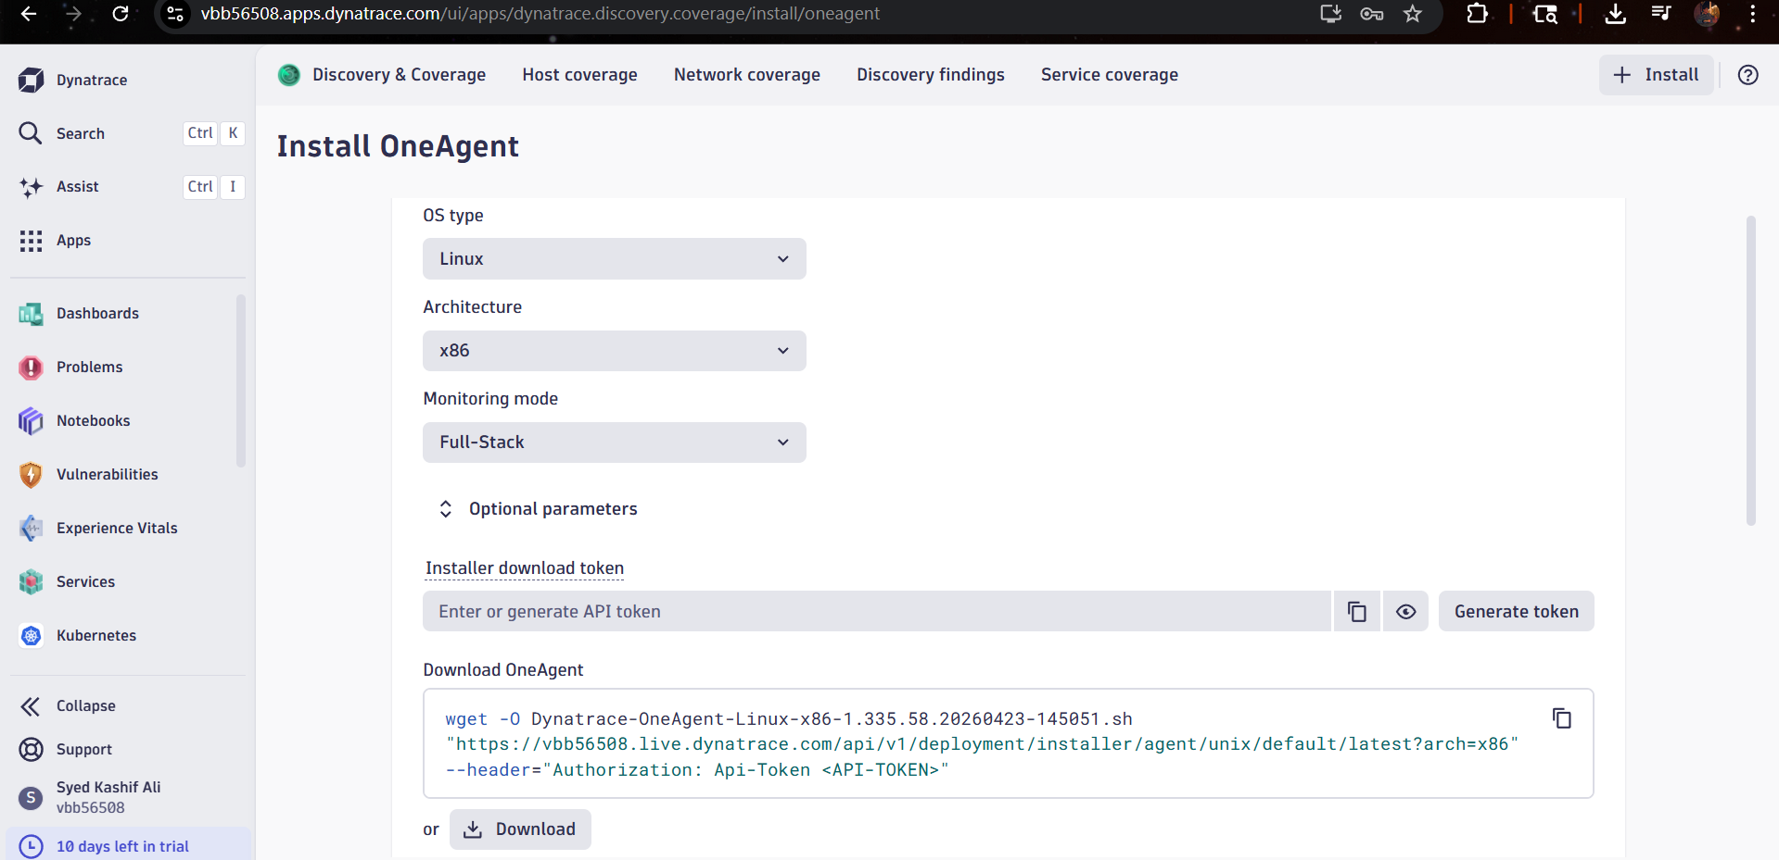
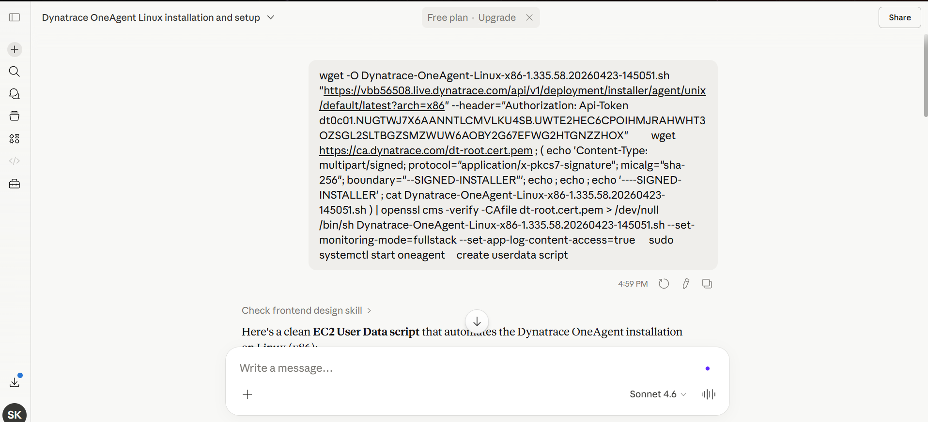

2. create a Launch Template and Select AMI Amazon Linux and add Key-pair, Security, Instance type, Don’t include subnets-AZ and add User-Data generated by Claude ai.

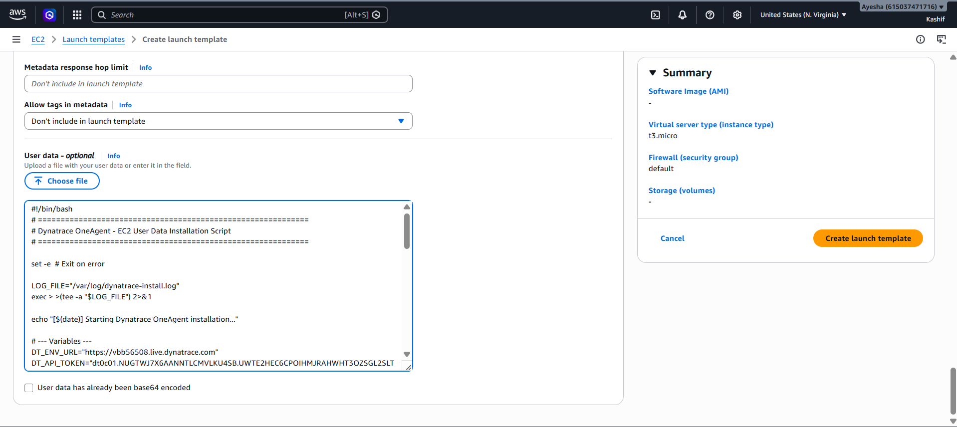

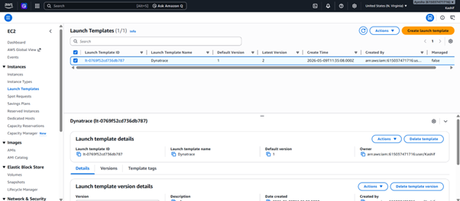

3. Now create ASG without Load balancer Directly Just for practice purpose select LT in A-S-G and select AZ add tags Name = Dynatrace

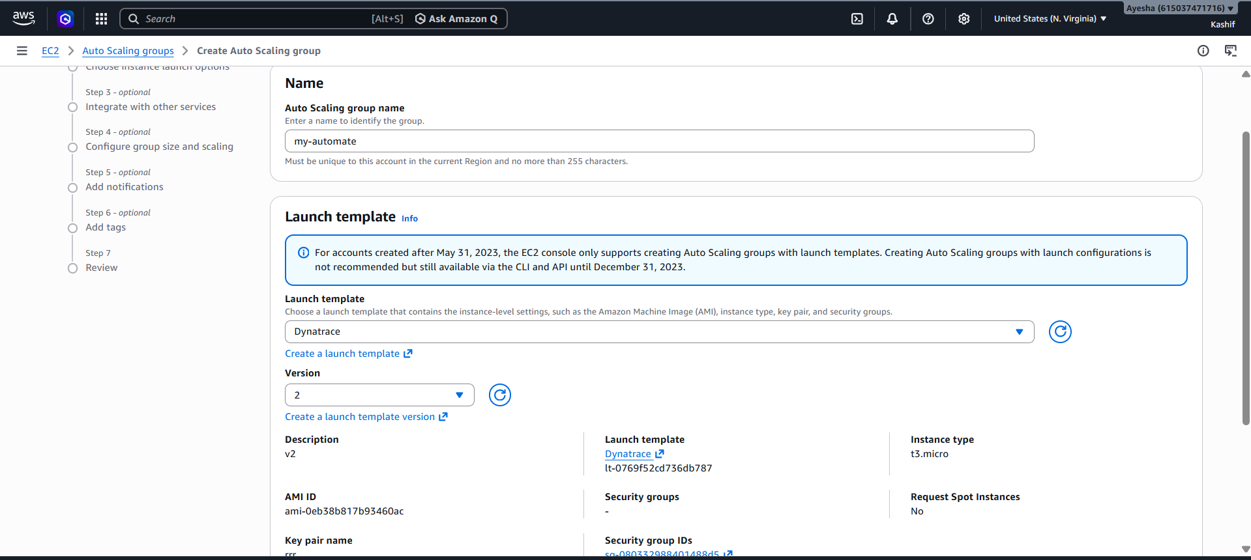

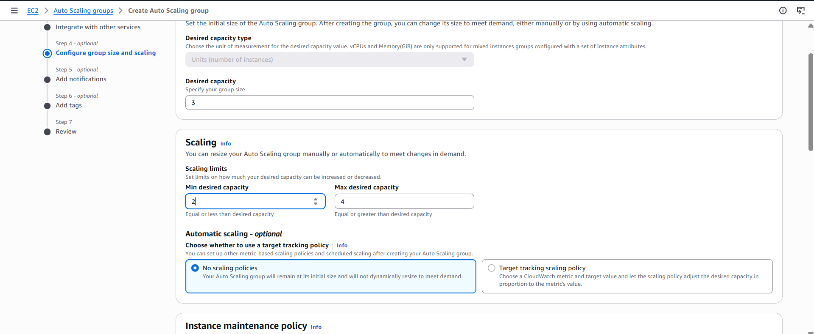

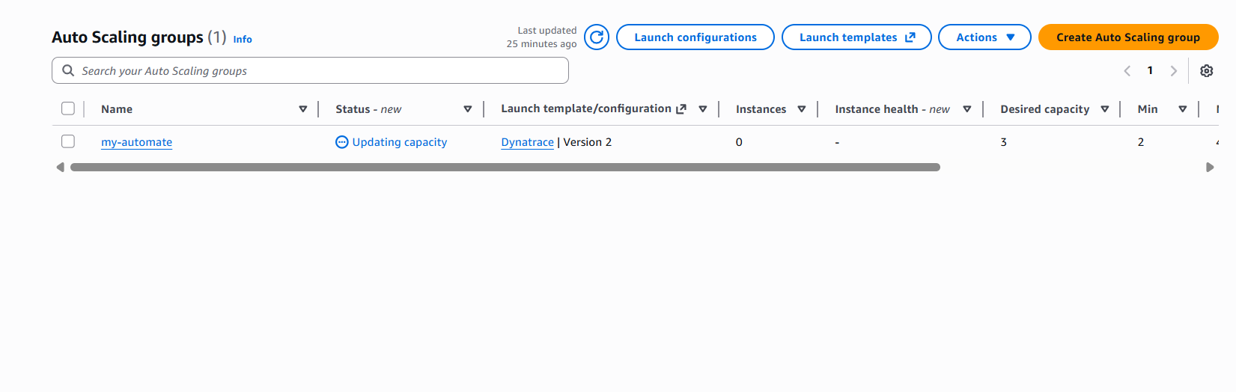

4.Now go to Dynatrace and search for Deployment Status there Updated Your Host.
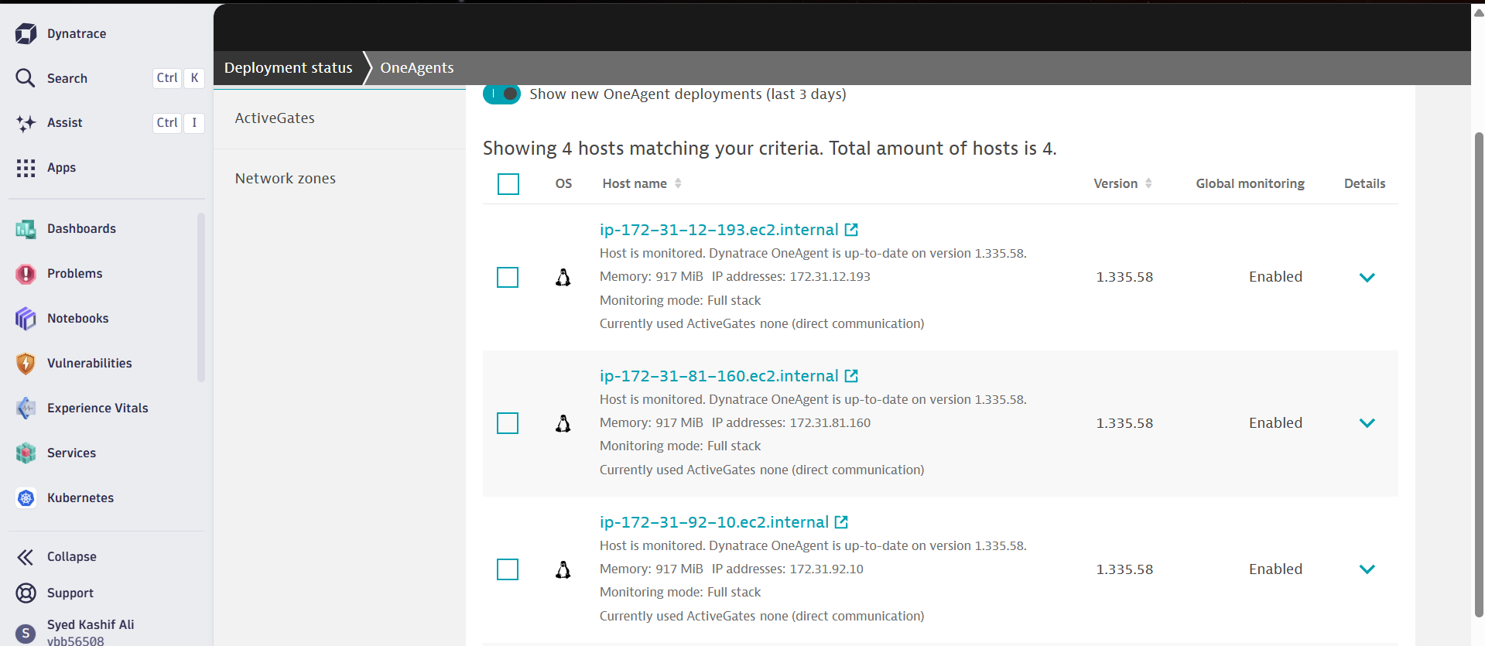
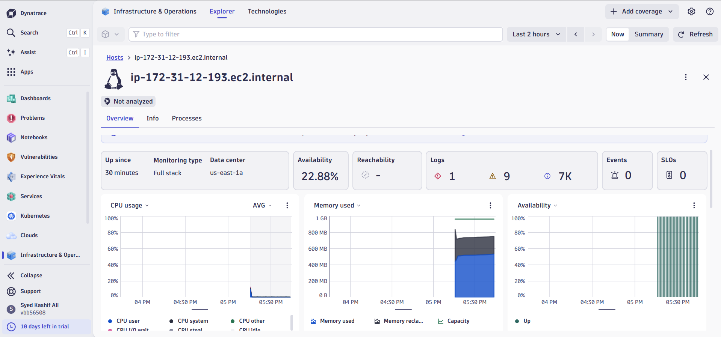

5.System Log is also pushed to Dynatrace of all hosts. If you wanna add custom logs you can add by go to Settings Capture and Collect Logs monitoring Custom Log Sources there you can add your Custom Path example :- /var/log/python-app/*.log Save it and restart OneAgent otherwise Wait for few minutes.

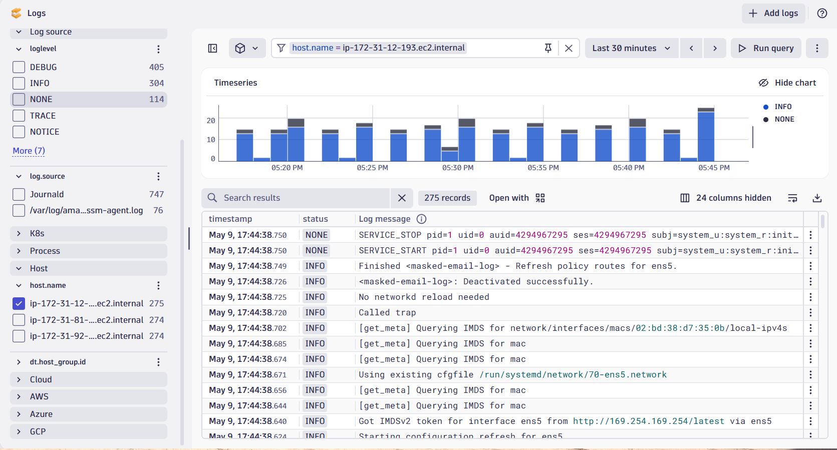
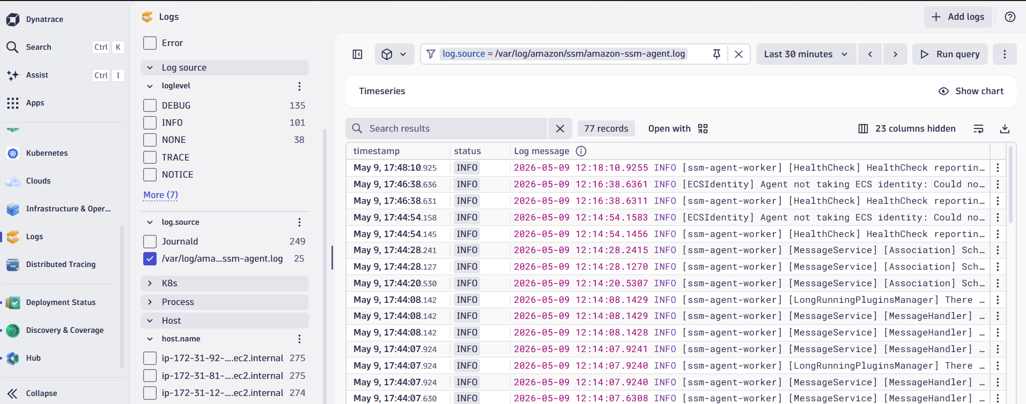

6. Go to dashboard Section click on plus + icon and click on Prompt and Give Prompt to create dashboard.

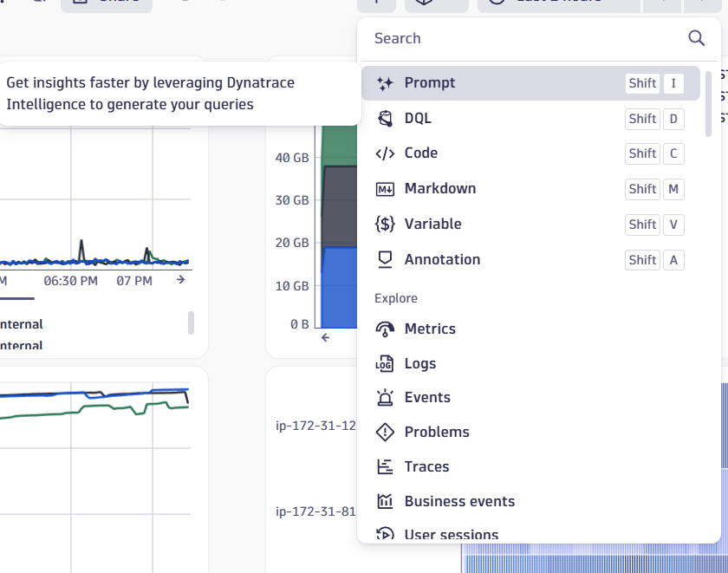

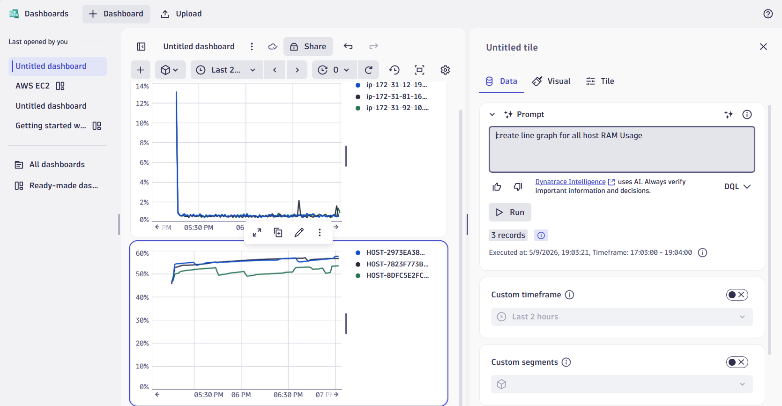

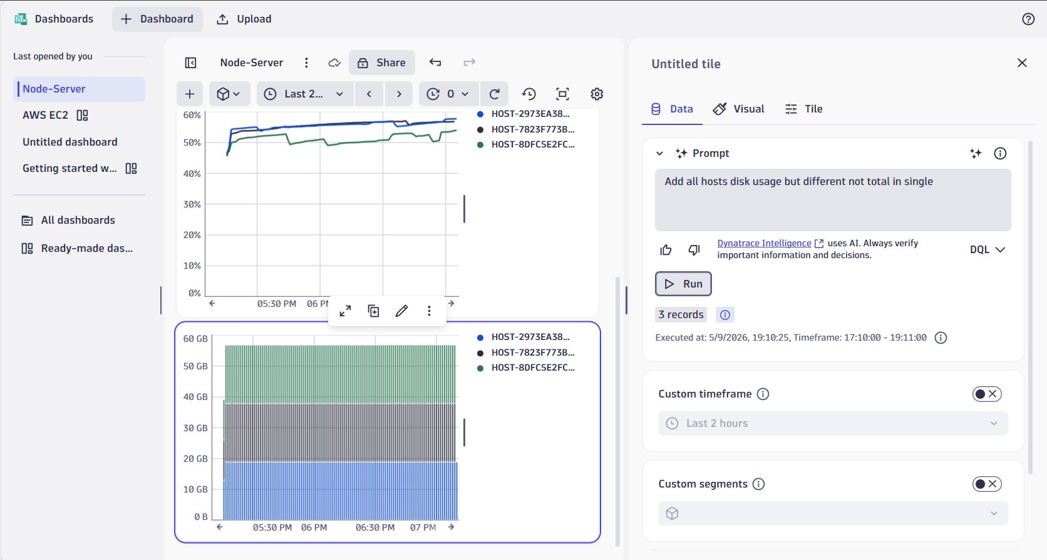
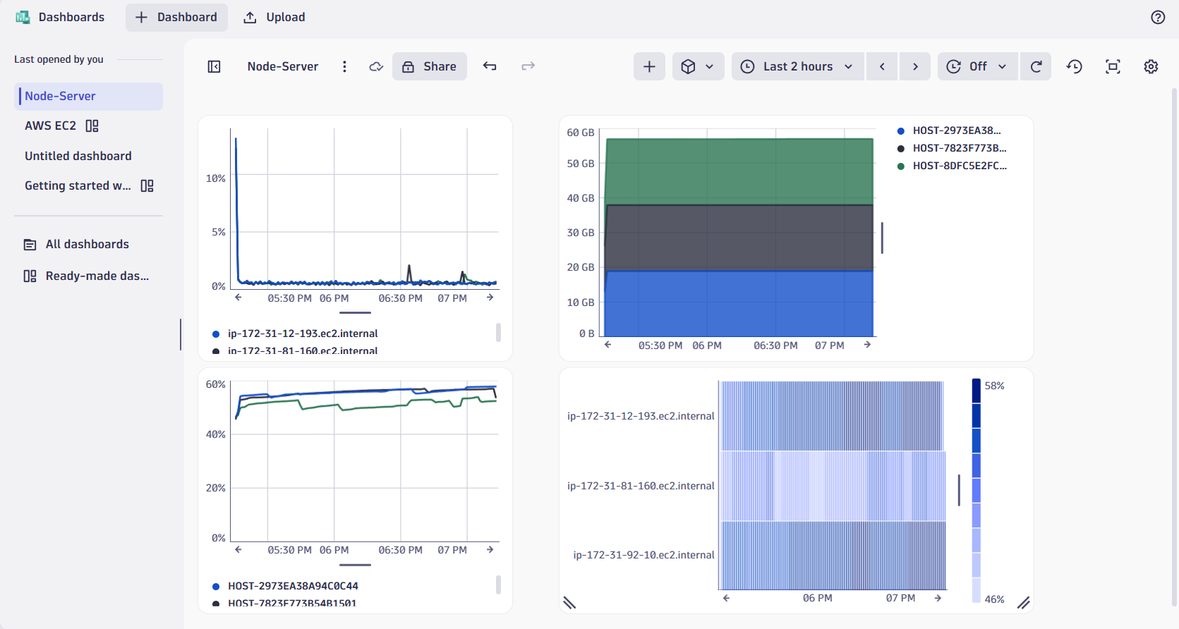

- Created By Syed Kashif Ali

